## GEOLOCATION BASED ACCIDENT/ FALL DETECTION FOR EMERGENCY SERVICES

Prepared By:

**Aditya Shukla (2020BTechCSE006)**

**Divyanshu Singh (2020BTechCSE030)**

**Prateek Sharma (2020BTechCSE093)**

**Rohan Sharma (2020BTechCSE066)**

Faculty Guide:

**Dr. Devika Kataria**

## 

**Department of Computer Science Engineering Institute of Engineering and Technology (IET)**

## TABLE OF CONTENTS

## ABSTRACT 3

## INTRODUCTION 4

## PROBLEM 5

## METHODOLOGY 6

## APPENDIX 18

## 3D MODELING 25

## REFERENCES 26

## Abstract

Millions of lives can be saved if an accident is discovered as soon as possible, and the caretakers are informed. Road accidents in India claimed the lives of 151,113 persons in 2019 and wounded 451,361. A further 138 million senior persons live in India alone and require care and attention when they are away from home. In order to prevent falls and accidents involving body impacts brought on by abrupt acceleration or deceleration, our team is developing a gadget that can detect these events. The apparatus is responsible for promptly informing those who are concerned of the location of the accident site. Anyone with a disability, including those caused by diabetes, dementia, or even those who are motorcyclists or drivers, can use the gadget.

**Introduction:**

When their children leave for work, many elderly folks live alone. This implies that if any mishaps occurred during this time, nobody could assist them. The elderly must call an ambulance or their relatives for assistance if they are hurt and fall, but this may not be possible.

Due to their bodies being weaker and losing physical strength, elderly individuals fall more frequently. They may become unconscious or be unable to rise up after falling, so they require assistance from others. Falling can result in a catastrophic injury or even death, especially when it involves the head. In a similar vein, almost two million kids are hospitalised annually for unintentional accidents and over 50 percent of these mishaps take place at home [1]. Children under the age of five are most at risk for injuries in the home environment where they spend the majority of their time, with falls accounting for more than 40% of all accidental injuries that occur there.

**Problem**

For elderly people and children, not able to timely contact family members when met with a accident or any mishap.

# **Solution**

# **We are Developing a device that can detect the fall of the person when an accident occurs so that the device can notify their family/ friends. This will help to reduce the latency/reaction time from the parents as well as the medical team when an accident occurs.**

**Methodology**

Ardunio IDE

Arduino IDE is an open-source software program that allows users to write and upload code in a real-time working environment. Arduino IDE is an easy-to-use programming software, that makes it simple for beginners to start programming. This means that you can use the Arduino IDE without being locked into proprietary boards.

While using programming software, it is easy to obtain the blueprints of a project. Arduino IDE supports several built-in libraries that were created specifically for the Arduino community.

In addition to using conventional compiler toolchains, Arduino provides an integrated development environment (IDE) and a command-line tool (Arduino-CLI) developed in Go. The Arduino integrated development environment (IDE) is a cross-platform (for Windows, macOS, and Linux) application written in the Java programming language. Arduino-compatible microcontrollers can all be programmed via the IDE.

The Arduino IDE v1 contains a text editor to write code, a message box, a text console, a toolbar with buttons for common functions, and several menus. The Arduino IDE for Windows is available in installation and compressed versions, so you can install Arduino IDE using the preferred method. Open a browser and head over to the Arduino site to download an installer for your OS.

You can revert Arduino IDE v1 to the default setting by selecting the default language according to your operating system and selecting the System Default option in the editor language dropdown. Then, use Board Manager to install the latest versions of the Arduino SAMD, Adafruit AVR, Adafruit SAMD, ESP8266, and esp32, and restart the v2 IDE. Using Board Manager Find out how the new Board Manager Tool works, and how to install your desired boards with ease into The Arduino IDE 2.0.

In this tutorial, we are going to show how you can install an ESP32 board into the Arduino IDE, regardless of if you are using Windows, Mac OS X, or Linux. Using Arduino IDE, users can create sketches directly in a text editor. In August 2018, Arduino announced their new open-source command-line tool (Arduino-CLI), which can be used in place of IDE for programming Arduino boards from the shell. (*Arduino IDE 2 Tutorials*, n.d.)

Node MCU

NodeMCU includes firmware running on an Espressif Systems Espressif Systems ESP8266 WiFi SoC, as well as hardware that is based on an Espressif Systems EP-12 module. The Nodemcu development board has hardware that is mostly based on the ESP-12 module, and firmware that runs on the Espressif Systems ESP8266 Wireless SoC.

NodeMCU is based on the eLua Project and built with Espressif Systems non-OS SDK for esp8266. The Nodemcu development board is built using the Espressif Non-OS SDK for the ESP8266 and is based on the eLua project.

The development board, called the Nodemcu, uses an ESP8266 and the same firmware. The development board includes the Silicon Labs CP2102 USB-to-UART bridge controller, which converts USB signals into serial data, allowing your computer to program and talk to the esp8266 chip.

Once you have installed Arduino IDE on the computer, you use the USB cable to connect the NodeMCU to your computer. After those two steps, you will be able to see the ESP8266-based boards like the NodeMCU on the board list of Arduino IDE and can select your desired board to load the code.

Just like the regular Arduino, the esp8266 has digital input/output pins (I/O, or GPIO, general purpose input/output pins). The ESP8266 has 17 GPIO pins (0-16), however, you can use only 11 of these because six of them (GPIO 6-11) are used for connecting to a flash memory chip.

The NodeMCU for the ESP8266 has 17 GPIO pins in total, which are broken down into the pin headers on either side of the development board. Just like Arduino boards, the ESP8266 NodeMcu has the GPIO pins, voltage regulator, ADC, and micro-USB port (for flash memory and serial out) all in the same board. The total number of pins of the ESP8266 NodeMCU is 30, which connects the ESP8266 NodeMCU to the external world.

The ESP8266 has built-in AT command firmware that can be used with any microcontroller over the COM ports. NodeMCU is an open-source platform built around the ESP8266 that can link objects together and allow for data transmission using Wi-Fi protocol. NodeMCU is open-source firmware, with available prototype board designs and Open Source prototyping board designs.

NodeMCU is open source, Lua-based firmware for Espressifs ESP8266 WiFi SOC, and uses a SPIFFS filesystem on-module, based on Flash. NodeMCU (Node Microcontroller Unit) is an open-source software and hardware development framework built around a low-cost System-on-a-Chip (SoC) called the esp8266. The ESP8266 System-on-a-Chip (SoC) serves as the basis for Nodemcu, an open-source software, and hardware development environment. (J, 2022)

MPU 6050

The MPU-6050 with a six-axis was sometimes called a 6DOF device (six degrees of freedom) because MPU6050 Sensor provides six output values (three by accelerometer, three by gyro). The accelerometer used in the MPU-6050 is a three-axis accelerometer, meaning that it perceives acceleration in the X, Y, and Z axes. The three-axis accelerometer measures acceleration in the same way that was explained in a previous video about the ADXL345 Accelerometer Sensor.

In the case of the MPU6050 sensor, is a 6-axis movement tracking device that integrates 3-axis Accelerometer and 3-axis Gyroscope in one chip. The MPU6050 IMU is also called a six-axis motion tracking device or 6-DOF (six degrees of freedom) device due to the fact of having six outputs, that is, the outputs from 3 accelerometers and the outputs from 3 gyroscopes. The MPU6050 is an inertial measurement unit (IMU) that integrates the mems gyroscope and accelerometer and uses the standard I2C bus for data communications.

The MPU6050 has an on-chip gyroscope and accelerometer sensors, as well as temperature sensors. MPU6050 is a Micro-Electro-Mechanical System (MEMS), which is composed of a 3-axis accelerometer and 3-axis gyroscope. At the heart of MEMS sensors is the low-power, low-cost 6-axis motion tracking chip -- the MPU6050 -- which combines a 3-axis gyroscope, 3-axis accelerometer, and digital motion processor (DMP) in a small 4mm by 4mm package.

The MPU6050 module also has a within itself (DMP) Digital Motion Processor, powerful enough to do complicated calculations, thus releasing work for microcontrollers. Since IIC addresses for modules are configurable, it is possible to interface more than one sensor of MPU6050 with Microcontroller using 7 AD0. The lower-power has on-chip acceleration sensors which can measure acceleration in four full-scale, programmable ranges: +-2g, +-4g, +-8g, and +-16g. (*Getting Started With Arduino and MPU6050. Interfacing MPU-6050 With Arduino.*, 2021)



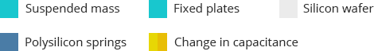

Coriolis effect

Coriolis forces shift weather patterns around in circles, an example of the effect of the force of gravity. Storms, known as cyclones, tend to move in the opposite direction across each hemisphere, due to the Coriolis force, too. The Coriolis force is a pseudo-force that acts on all rotating frames.

The component of vibrations caused by the rotational force of Coriolis is exactly like that caused by drive-driven vibrations. Figure 4, showing a full framework, shows that when the resonance mass moves, and when the surface on which the gyroscope is mounted is rotating, the mass and the polysilicon framework undergo the acceleration due to the Coriolis and are translated by 90deg relative to the vibrational motion.

The centrifugal pseudo-force, at a direction, drives the mass away from the axis and is counterbalanced by tension on the shaft of the gyroscope, such that it can (correctly) be expected to sum to zero. We have also ignored the final term at the right in Eq., axis constant. When the rate of rotation, O z, is introduced along the z-axis, the Coriolis force, F c = 2mO z V y, forces tines to swing on the axes of sensation, with amplitude, Dx, related to the rotation rate, O z, ref.

Since the gyroscope disc is rotating about the horizontal (x-) axis, the couple is perpendicular to the rotating axis of the gyroscope and the axis of rotation will move in the direction of the couple (because of Newton's laws for rotational motion), so the axis will move out of the page. The tuning fork used in this work may be excited such that two masses with an equal amount of resistance are forced into an antiphase oscillation on the driving axis. Any osculating torque on the Z-axis (due to externally applied rotating vibrations) does not combine with vibrations in the walls of the case. (*Coriolis Effect*, n.d.)

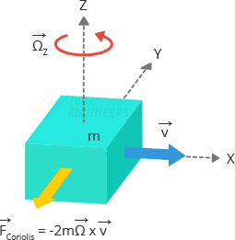

Figures representing gyroscope moving in all 3 direction.







Geolocation API?

The geolocation API allows a user to give his or her location to a web app if he or she wants. The Geolocation API is accessed by calling Navigator. geolocation: this will result in the user's browser asking for the user's permission to access their location data. The Geolocation API returns the location and an accuracy radius, based on the information from the cellphone towers and Wi-Fi nodes the mobile client can detect.

We showed how these can be used in conjunction with Google Maps APIs to create a full-featured service for tracking the position of users and pinpointing their locations on maps.

If you would like to integrate personalized Google maps into your site or app, then the Google Maps API is what you should use. Pricing for Google Maps, routes, and locations, as well as the APIs connected to Google Maps (Maps JavaScript API, directions API, time zone API, geocoding API), is paid-as-you-go, so you pay for only what you use. After you complete the trial, Google will give $200 in credits each month towards your API use.

(*Overview | Geolocation API  |*, n.d.)

Threshold values used:

For trigger 1 the value of threshold in terms of g is acceleration in

For trigger 2 the value of threshold in terms of g is acceleration in

For trigger 3 the value of threshold set for gyroscope is that there should a change of 80-to-100-degree change in orientation and it should be constant for 10 minutes.

# Software Services Implemented

1. Node js
2. Firebase

Node JS

Node.js is an open-source server environment. Node.js is cross-platform and runs on Windows, Linux, Unix, and macOS. Node.js is a back-end JavaScript runtime environment. Node.js runs on the V8 JavaScript Engine and executes JavaScript code outside a web browser.

Node.js lets developers use JavaScript to write command line tools and for server-side scripting. The functionality of running scripts server-side produces dynamic web page content before the page is sent to the user's web browser. Consequently, Node.js represents a "JavaScript everywhere" paradigm, unifying web application development around a single programming language, rather than different languages for server-side and client-side scripts.

Node.js has an event-driven architecture capable of asynchronous I/O. These design choices aim to optimize throughput and scalability in web applications with many input/output operations, as well as for real-time Web applications (e.g., real-time communication programs and browser games). The Node.js distributed development project was previously governed by the Node.js Foundation and has now merged with the JS Foundation to form the OpenJS Foundation. OpenJS Foundation is facilitated by the Linux Foundation's Collaborative Projects program. Corporate users of Node.js software include GoDaddy, Groupon, IBM, LinkedIn, Microsoft, Netflix, PayPal, SAP, Walmart, Yahoo!, and Amazon Web Services.

Node.js allows the creation of Web servers and networking tools using JavaScript and a collection of "modules" that handle various core functionalities. Modules are provided for file system I/O, networking (DNS, HTTP, TCP, TLS/SSL, or UDP), binary data (buffers), cryptography functions, data streams, and other core functions. Node.js's modules use an API designed to reduce the complexity of writing server applications.JavaScript is the only language that Node.js supports natively, but many compile-to-JS languages are available. As a result, Node.js applications can be written in CoffeeScript, Dart, TypeScript, ClojureScript and others.

## Implementation of Node JS in Project

## Node js is used for sending information to the concerned party of the user. Initially, a Node js project is set up using the npm init command. Once, the project is set up, necessary libraries were installed such as Express, dotenv (for maintaining the confidentiality of important things like API_KEY, Auth Token etc.), request (for request-response communication), firebase and geocoder (for getting the location from Wi-Fi Mac Addresses). Firebase's real-time database will be accessed through the name 'test' for retrieving data.

Data regarding the accident such as Date, Time, Name, and Wi-Fi Mac Addresses are retrieved using Node js for further processing. After getting the required data, a post request will be sent to Google's Geolocation API with Wi-Fi access points as the body along API Key for the post request. It will return the latitude and Longitude of the Wi-Fi access points in JSON format. Further, the Geocoder library will be used to get the address of latitude and longitude.

Geocoder.reverse will take latitude and longitude as argument and return area neighbourhood, city, state, the country as well as zip code for that particular location. After that Google's Map link is created from latitude and longitude. Twilio is used for sending messages. Twilio is an online messaging service which provides free messaging services to registered mobile numbers. Finally, the Message is sent using Twilio.

The onValue function is used for continuously listening to the updates happening in the database. The onValue function re-executes the code written inside itself, once there is a change in the data of the database. It ensures as soon as the data is changed, meaning an accident has occurred, the message is automatically sent to the concerned party of the user. For running code, type nodemon in the terminal of VsCode.

**Code Output: -**

1. Starting Application

1. Retrieving Latitude and Longitude from Wi-Fi Access Points also getting address from Latitude and Longitude

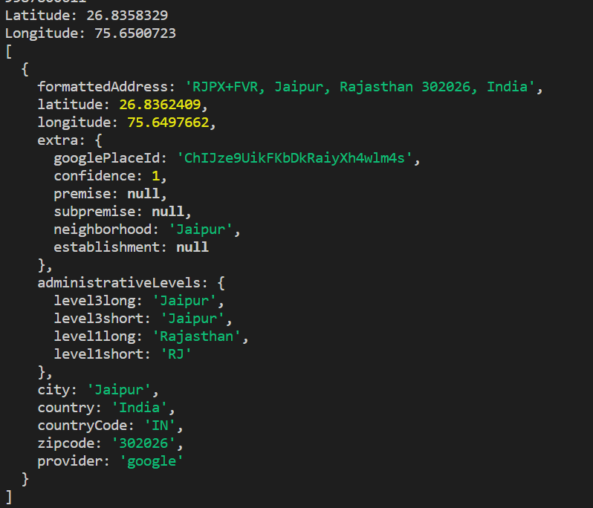

1. Sending message to the concerned Party

Firebase

Firebase is a set of hosting services for any type of application (Android, iOS, Javascript, Node.js, Java, Unity, PHP, C++ ...). It offers NoSQL and real-time hosting of databases, content, social authentication (Google, Facebook, Twitter and GitHub), and notifications, or services, such as a real-time communication server.

It provides tools to build apps, grow audiences, and make money from your apps through analytics, database services and advertising products. In addition to the core services provided by the Firebase SDKs (software development kits), there are additional features that can be used with Firebase such as Crash Reporting & Analytics, Dynamic Links for iOS/Android push notifications and Cloud Messaging for cross-platform messaging between Android & iOS devices.

Implementation of Firebase in Project

Firebase has been used to store user's information once, accident has been detected. Firebase Realtime database has been used for accomplishing this task. Data is uploaded directly on the Firebase Realtime Data base, through NodeMCU.

The data uploaded are Date, Time and MAC Addresses of nearby Wi-Fi Routers. This information is then fetched using Node js and sent to the concerned party of the user with Google Maps Link for getting more precise location of the accident.

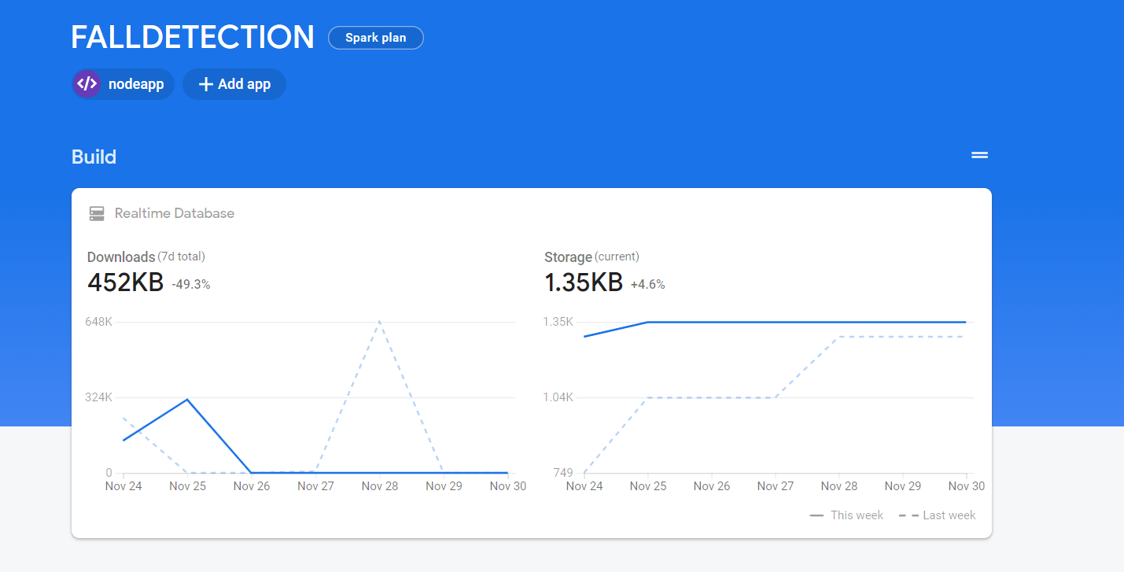

**3D Modeling**

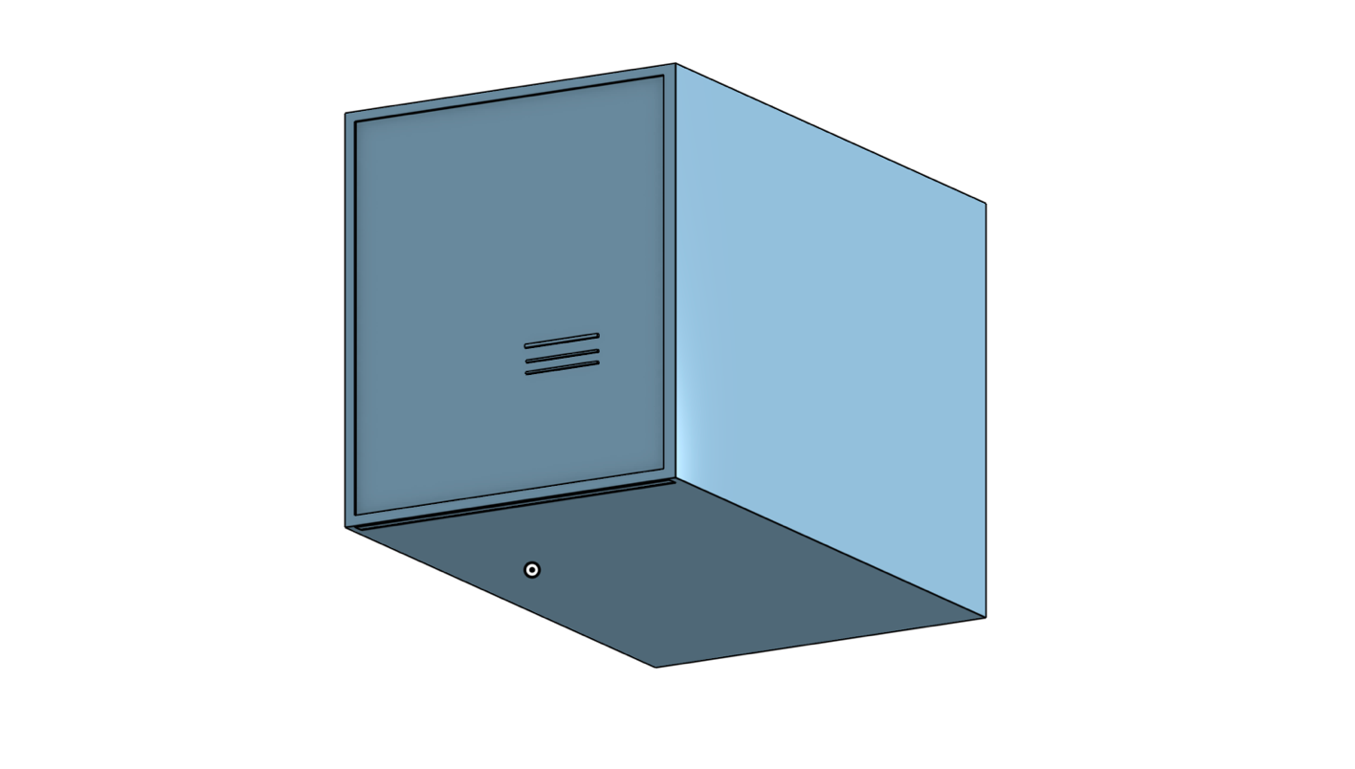

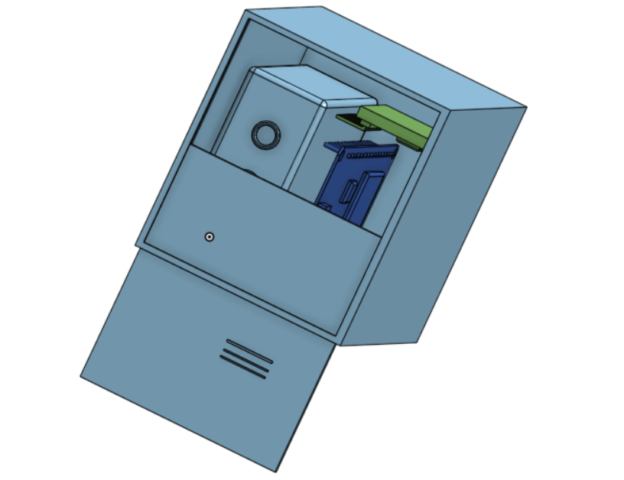

**Conclusion and Future scope**

1. We have successfully developed a prototype during the initial testing we were able to find get the exact location of the accident with 60 m accuracy.
2. We are planning to make it more suitable to carry like in a bag or on a walking stick or wearable like a pager.

**References** :

*1. Getting Started with Arduino and MPU6050. Interfacing MPU-6050 with Arduino.* (2021, September 7). Electronics Hub. <https://www.electronicshub.org/getting-started-arduino-mpu6050/>

*Overview  |  Geolocation API  |*. (n.d.). Google Developers. <https://developers.google.com/maps/documentation/geolocation/overview>

J, J. (2022, March 26). *NodeMCU ESP8266 Specifications, Overview and Setting Up*. Make-It.ca. <https://www.make-it.ca/nodemcu-details-specifications/>

*Coriolis effect*. (n.d.). <https://www.analog.com/en/technical-articles/mems-gyroscope-provides-precision-inertial-sensing.html>

*Arduino IDE 2 Tutorials*. (n.d.). Arduino Documentation. <https://docs.arduino.cc/software/ide-v2>

**Appendix**



